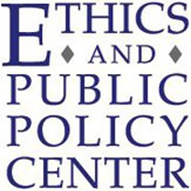
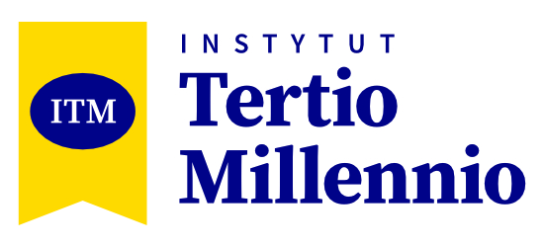

TERTIO MILLENNIO SEMINAR
ON THE FREE SOCIETY
7th JULY – 26th JULY 2025
CRACOW, POLAND

- APPLICATION FORM -
PERSONAL DETAILS
First name
Family name
Nationality
Date of birth
Home address
City
State
Zip code
Country
Mailing address
(if different from home address)
E-mail
Telephone
(with area code)
Contact telephone
(if needed)

EDUCATION
Studies - I faculty
University
Main subject
Level (BA, MA, PhD)
Year of completion
Studies - II faculty (optional)
University
Main subject
Level (BA, MA, PhD)
Year of completion
Other faculties or courses taken
ACADEMIC WORK
Student activities
Research projects
Academic awards
Topics of major papers
Future educational plans

COMMUNITY SERVICE
Type of activity (I)
Period
Functions
Duties
PROFESSIONAL EXPERIENCE
Position taken (I)
Period
Job description
Position taken (II)
Period
Job description

LANGUAGES
Language | Level (A1/ A2/ B1/ B2/ C1/ C2)
Language certificates
OTHER INFORMATION
Personal interests
Other information
(if you would like to provide any other)
MOTIVATION
Why would you like to participate in TMS?
Up to 400 words.
How do you think you could use the knowledge gained during the Seminar?
Up to 300 words.
How do you understand the terms democracy and free society?
Up to 300 words.

Are the ideas of democracy and free society interesting to you? Why?
Up to 300 words.
Are you interested in Catholic Social Teaching? Why?
Up to 300 words.
How, in your opinion, can the Catholic Social Teaching be useful to a modern society?
Up to 300 words.
What do you think was the proudest moment of your life?
Up to 400 words.
How did you get to know about the TMS?

Thank you for filling in our Tertio Millennio Seminar of the Free Society
application form!

To complete your application send the following application form in the PDF form along with your up-to-date photo and up to 2 letters of recommendation to seminar@tertio.pl before the final deadline 30 April 2025. In the subject of your message enter your name, age, and country of origin, for example:
Jane Smith, 24, Poland.

If you have any questions concerning application process, contact Tertio Millennio Institute using following e-mail address: seminar@tertio.pl. For additional information please go to www.seminar.tertio.pl or visit our Facebook fanpage.

